### 

### Semester One Examination, 2020

### Question/Answer booklet

# MATHEMATICS METHODS

**UNIT 1**

## Section Two:

## Calculator-assumed

Your Name

Your Teacher’s Name

## Time allowed for this section

Reading time before commencing work: ten minutes

Working time: one hundred minutes

## Materials required/recommended for this section

***To be provided by the supervisor***

This Question/Answer booklet

Formula sheet (retained from Section One)

***To be provided by the candidate***

Standard items: pens (blue/black preferred), pencils (including coloured), sharpener, correction fluid/tape, eraser, ruler, highlighters

Special items: drawing instruments, templates, notes on two unfolded sheets of A4 paper, and up to three calculators approved for use in this examination

## Important note to candidates

No other items may be taken into the examination room. It is **your** responsibility to ensure that you do not have any unauthorised material. If you have any unauthorised material with you, hand it to the supervisor **before** reading any further.

| **Question** | **Marks** | **Max** | **Question** | **Marks** | **Max** |
| --- | --- | --- | --- | --- | --- |
| **9** |  | **9** | **17** |  | **7** |
| **10** |  | **8** | **18** |  | **11** |
| **11** |  | **5** | **19** |  | **6** |
| **12** |  | **8** | **20** |  | **8** |
| **13** |  | **7** | **21** |  | **6** |
| **14** |  | **10** |  |  |  |
| **15** |  | **5** |  |  |  |
| **16** |  | **10** |  |  |  |

**Structure of this paper**

| Section | Number of questions available | Number of questions to be answered | Working time (minutes) | Marks available | Percentage of examination |
| --- | --- | --- | --- | --- | --- |
| Section One:  Calculator-free | 8 | 8 | 50 | 50 | 33 |
| Section Two:  Calculator-assumed | 13 | 13 | 100 | 100 | 67 |
|  |  |  |  | **Total** | 100 |

**Instructions to candidates**

1. The rules for the conduct of the Western Australian Certificate of Education ATAR course examinations are detailed in the *Year 12 Information Handbook 2020*. Sitting this examination implies that you agree to abide by these rules.
2. Write your answers in this Question/Answer booklet.
3. You must be careful to confine your answers to the specific questions asked and to follow any instructions that are specific to a particular question.
4. Additional pages for the use of planning your answer to a question or continuing your answer to a question have been provided at the end of this Question/Answer booklet. If you use the space to continue an answer, indicate in the original answer space where the answer is continued, i.e. give the page number.
5. **Show all your working clearly.**Your working should be in sufficient detail to allow your answers to be checked readily and for marks to be awarded for reasoning. Incorrect answers given without supporting reasoning cannot be allocated any marks. For any question or part question worth more than two marks, valid working or justification is required to receive full marks. If you repeat any question, ensure that you cancel the answer you do not wish to have marked.
6. It is recommended that you **do not use pencil**, except in diagrams.
7. The Formula sheet is **not** to be handed in with your Question/Answer booklet.

**See Next Page**

**Section Two: Calculator-assumed (100 Marks)**

This section has **thirteen (13)** questions. Answer **all** questions. Write your answers in the spaces provided.

Spare pages are included at the end of this booklet. They can be used for planning your responses and/or as additional space if required to continue an answer.

● Planning: If you use the spare pages for planning, indicate this clearly at the top of the page.

● Continuing an answer: If you need to use the space to continue an answer, indicate in the original answer space where the answer is continued, i.e. give the page number. Fill in the number of the question that you are continuing to answer at the top of the page.

Working time: 100 minutes.

**Question 9 {1.1.23, 1.1.24, 1.1.25} (9 marks)**

1. Circle the diagrams that show functions. (2 marks)



| (i) |
| --- |
| (ii) |
| (iii) |
| (iv) |

1. State the domain and range for the following functions. (4 marks)

|  | Domain:  Range: |
| --- | --- |

|  | Domain:  Range: |
| --- | --- |

1. If find (3 marks)
2. -1

**Question 10 {1.3.13, 1.3.15, 1.3.16} (8 marks)**

In a school survey of 207 students in Year 11 and Year 12, it was observed that 77 of the 102 Year 12 students studied Mathematics and the 10 students in Year 11 did not study Mathematics.

If one student is selected at random from those surveyed, determine the probability that

1. they were in Year 11. (1 mark)
2. they studied Mathematics. (1 mark)
3. they were in Year 12 or studied Mathematics. (2 marks)
4. They studied Mathematics given they were in Year 11. (2 marks)
5. Without calculating any further probabilities, is there any indication that studying Mathematics is independent of Year? Justify your answer. (2 marks)

**Question 11 {1.1.3, 1.1.4, 1.1.5} (5 marks)**

Consider the graph shown:

1. Find the gradient of the line PQ. (2 marks)
2. Find the equation of the line RS. (2 marks)
3. Find the coordinates of point S. (1 mark)

**Question 12 {1.1.7, 1.1.10, 1.1.12} (8 marks)**

Use your ClassPad to display parabolas , and whose equations are

1. Write down a feature these three parabolas have in common. (1 mark)
2. Write down the turning point for each parabola and state its nature. (3 marks)
3. Write down the equation of in turning point form and state the line of symmetry.

(2 marks)



1. If the graph of is translated 2 units in the positive direction of the x axis and 2 units in the negative direction of the y axis, write down the new equation for and state its new line of symmetry.

(2 marks)

**Question 13 {1.1.15} (7 marks)**

Sketch the graphs of the following functions. Draw and label the key features, including x- and y-intercepts, vertices, asymptotes (if relevant), showing correct general shape and behaviour.

1. (4 marks)



|  |
| --- |

1. (3 marks)

**Question 14 {1.1.18} (10 marks)**

1. Sketch the graph of each of the following function, labelling intercepts, point of inflection and showing the shape and behaviour as and .
2. (2 marks)

1. (3 marks)

1. Express cubic function in its factorised form and sketch its graph, labelling all intercepts and using arrows to show its shape and general behaviour as and

(5 marks)



|  |
| --- |

**Question 15 {1.1.13} (5 marks)**

An online company that sells onesies has modelled their expected number of daily sales (S) against the average daily temperature (T) in .

Their model has S as inversely proportional to for .

On a 10 day in August they sold 20 onesies.

1. Determine the relationship between S and T. (3 marks)
2. Determine the **number of expected sales** tomorrow if the average forecasted temperature is 29. (2 marks)

**Question 16 {1.1.14} (10 marks)**

1. State all the asymptotes on each graph below then determine each equation of the rectangular hyperbola:
2. (3 marks)

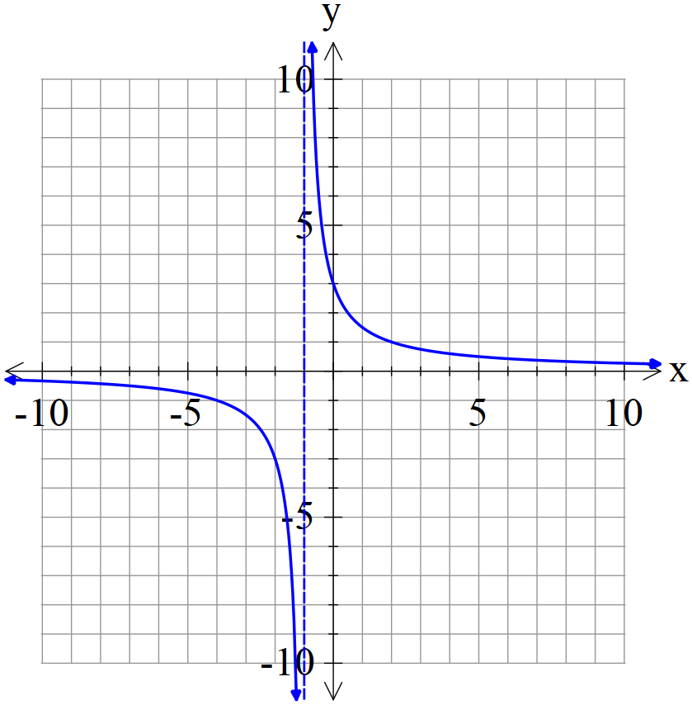

1. (3 marks)

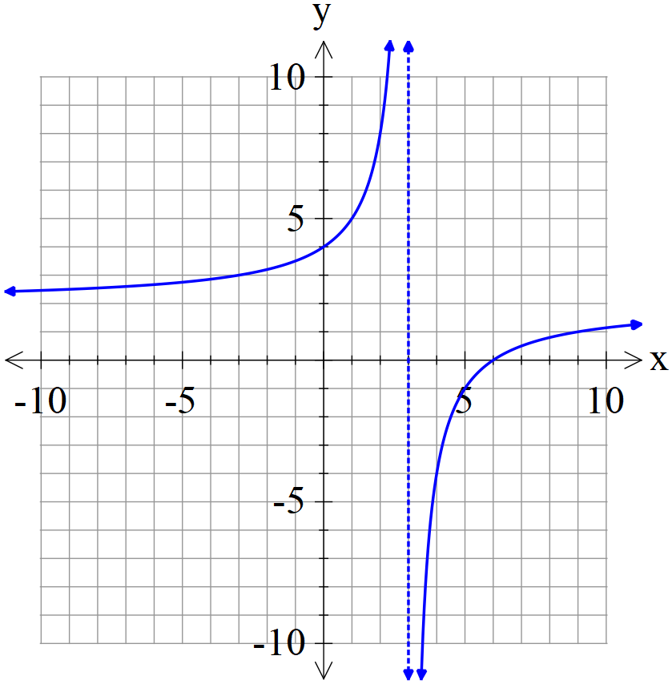

1. Complete the table below.

(4 marks)

| **Curve** | **x-intercept** | **y-intercept** | **Asymptote parallel to the** | |
| --- | --- | --- | --- | --- |
| **x-axis** | **y-axis** |
|  |  |  |  |  |
|  |  |  |  |  |

**Question 17 {1.1.10} (7 marks)**

A C-9 jet utilised by NASA enters a parabolic flight at an altitude of 9200m to simulate zero gravity. For the duration of the zero-gravity flight, its altitude in metres can be represented as a function of time in seconds as follows:

1. Given that the function passes through the points and , determine the values of , and . (3 marks)
2. When is the maximum altitude reached by the jet? State the maximum altitude.

(2 marks)

1. Given that the plane exits the parabolic flight at the same altitude it begins at, what is the duration of the zero-gravity simulation? (2 marks)

**Question 18 {1.1.26, 1.1.27} (11 marks)**

1. Let
2. What is the equation of the new function if is translated 4 units to the right and 3 units down? What are the coordinates of the point of inflection?

(3 marks)

1. Find the coordinates of the point of inflection of the function .

(2 marks)

1. State the sequence of graphical transformation(s) which occurs if:
2. (2 marks)
3. (4 marks)

**Question 19 {1.1.26, 1.1.27} (6 marks)**

The graph shows the function 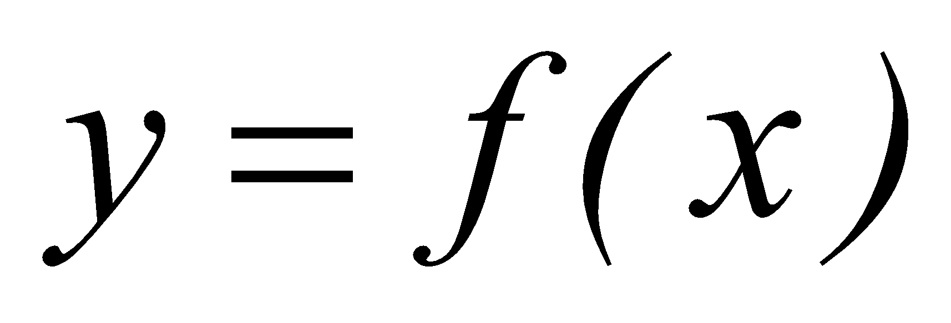.

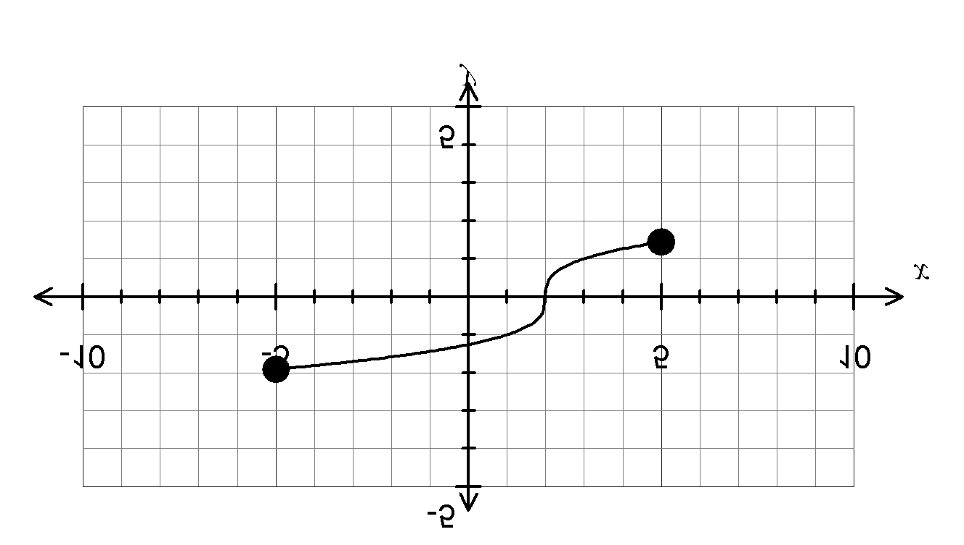

(a) Sketch the graph of 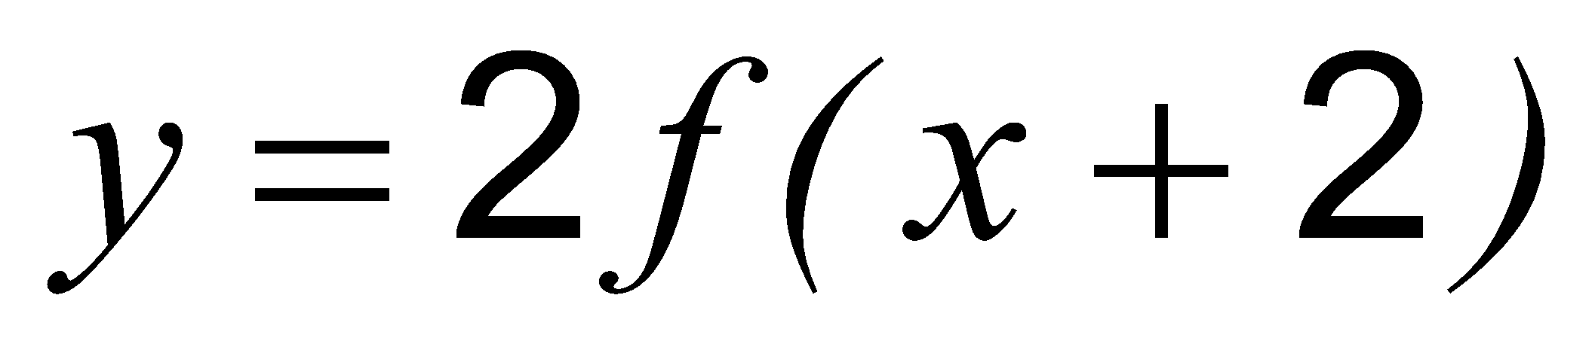. (3 marks)

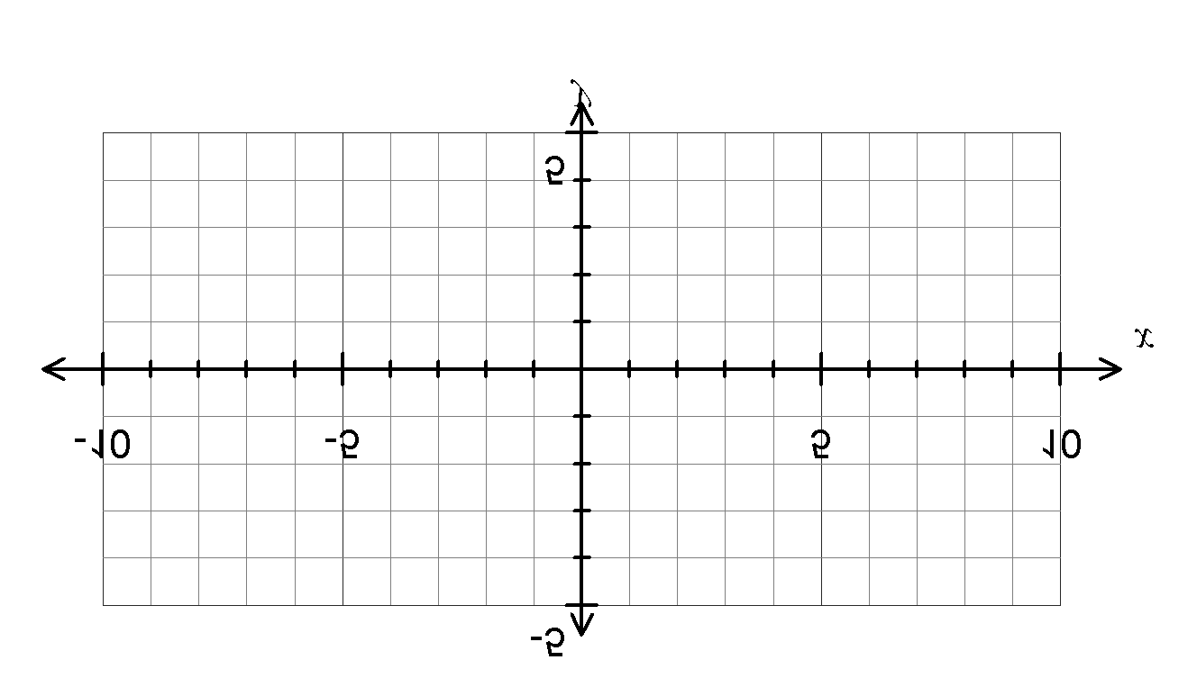

(b) Sketch the graph of 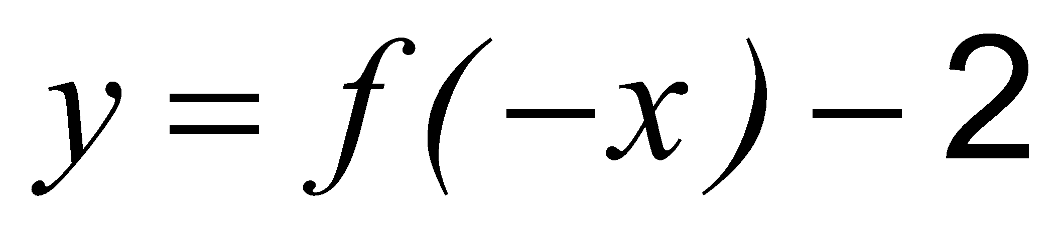. (3 marks)



**Question 20 {1.3.11, 1.3.12, 1.3.17} (8 marks)**

1000 people were studied to see if they contracted an illness (I) and whether they were vaccinated against it (V). 86 people caught the illness and 348 were vaccinated, including 1 person who caught the illness despite being vaccinated.

1. Given that the above data is representative of a population, find the probability that a person randomly selected from the population:
   * 1. is not vaccinated? (2 marks)
     2. has caught the illness or is vaccinated? (2 marks)
2. Does the vaccination affect a person’s probability of catching the illness? If it does, how is it affected? Justify your answer with calculations. (4 marks)

**Question 21 {1.1.20} (6 marks)**

It is found that the shape of a part of a roller coaster ride can be modelled by a cubic function for . The coordinates of several points on the track are (2, 360.5), (6, 195.14), (10, 54.74) and (12, 87.5).

(a) Determine the rule for the function in the form for Find the values of , , and *.*  (4 marks)

(b) Find the coordinates of the point(s) on the track that is furthest from the ground.

(2 marks)

**END OF QUESTIONS**

**Additional working space**

Question number:

**Additional working space**

Question number:

**Additional working space**

Question number: